**~ Test Plan for Slim Data Database System ~**

1. **Scope of the test:**

* Purpose: To validate that the slim data database system meets user and system requirements.
* Scope: Testing the functionality, data validation, and usability of the database system.
* Test Environment:

Hardware:

* Processor: Intel(R) Core (TM) i5-8265U CPU @ 1.60GHz, 1800 Mhz, 4 Core(s), 8 Logical Processor(s)
* RAM: 8GB
* Storage: 500GB

Software:

* Operating System: Microsoft Windows 10 Home
* SQL Server Management Studio Management Studio 19
* Microsoft Visual Studio 2022
* Software package: Slim Data Gym Database System.
* Version: 1.0
* Revision: 1

1. **Test Objectives:**

* Validate user & system requirements, such as member registration, class creation, email, and nationality validation.
* Verify Constraints, data validation, and default values.

1. **Test Approach:**

* Test Levels: Unit testing, integrity testing.
* Test Types: Functional testing, and data validation testing.
* Test Techniques: Black box.

1. **Test Scenarios and Test Cases:**

Test Case 1: Gym member registration.

* Description: Verify that a member can be successfully registered in the database.
* Test Steps:
  + Enter valid member information (memberID, fName, lName, email, BOD, nationality, phone no., weight, height, msType).
  + Click the "Insert" button.
* Expected Result: The member should be successfully registered in the database.

Test Case 2: Email validation.

* Description: Validate that the system checks for unique email addresses during member registration.
* Test Steps:
* 1. Enter email address that is already in the database.
* 2. Click the "insert" button.
* Expected Result:

The system should display an error message indicating that the email address is already registered in the database.

Test Case 3: Class creation.

* Description: Test the creation of a new class in the database.
* Test Steps:
* Enter valid class information (classID, className, instructorName, duration, schedule).
* Click the "Create Class" button.
* Expected Result: The class should be successfully created and stored in the database.

Test Case 4: Nationality default value.

* Description: Verify that the system assigns a default nationality value when the user does not provide one.
* Test Steps:
* Enter member information without providing the nationality.
* Click the "insert" button.
* Expected Result: The system should assign the default nationality value of "Jordanian" to the member.

1. **Test Execution and Reporting:**

* Execute the test cases according to the defined steps.
* Document the actual results and compare them to the expected results.
* Take screenshots of the test cases and their actual results and explain them.

Q: provide relevant test cases (at least 4 test cases) for the database you have implemented (Slim Data Database System). Note: You need to provide your answer with screenshots of the test cases with their actual results and explain them.

A:

|  |  |  |  |  |  |
| --- | --- | --- | --- | --- | --- |
| Case ID | Test scenario description | Test steps | Expected result | Actual result | Status |
| TC_SG_001 | Gym member registration  Verify that a member can be successfully registered in the database. | 1. Enter valid member information (memberID, fName, lName, email, BOD, nationality,phone no.,weight,height,msType).  2. Click the "Insert" button. | The member should be successfully registered in the database. | The member successfully registered in the database. | Pass |

First, I entered valid member information according to the test steps in the test plan using visual studio, as shown in the screenshots, followed by a pop-up message showing the information I entered and another message confirming the information insertion is completed.

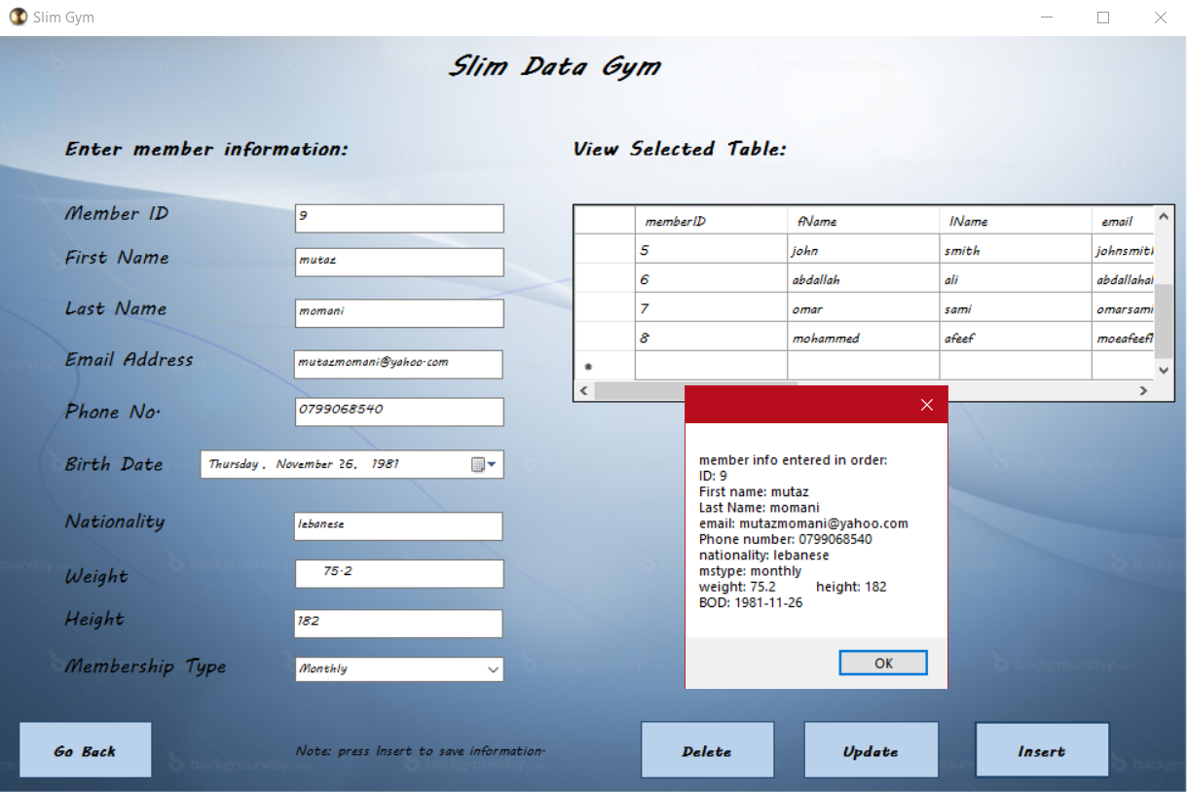

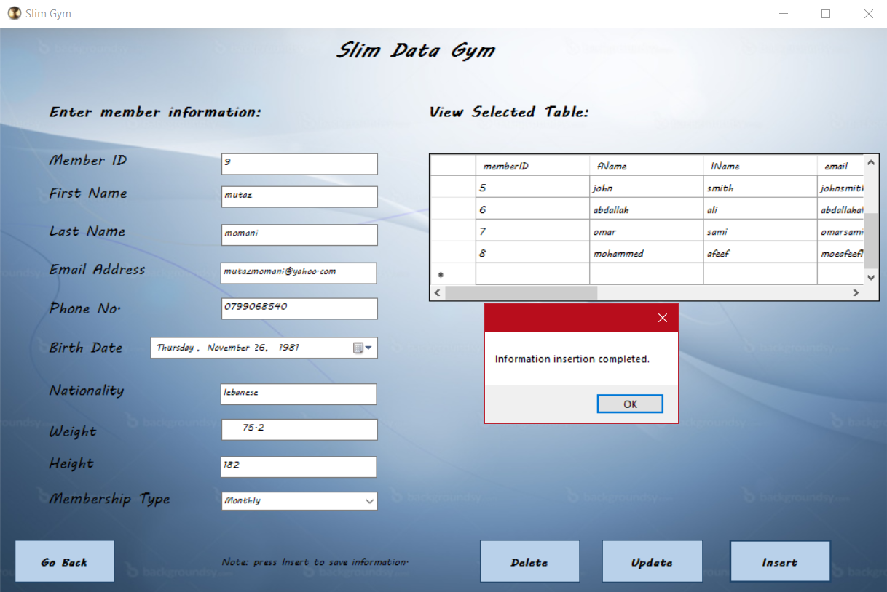

After that I checked the database using MSSMS to confirm that the information was updated correctly in the tables, and making sure the phone number is registered correctly to another table called memberPhoneNumber, to confirm the foreign key is working.

|  |  |  |  |  |  |
| --- | --- | --- | --- | --- | --- |
| Case ID | Test scenario description | Test steps | Expected result | Actual result | Status |
| TC_SG_002 | Email validation.  Validate that the system checks for unique email addresses during member registration. | 1. Enter email address that is already in the database.  2. Click the "insert" button. | The system should display an error message indicating that the email address is already registered in the database. | The system displayed an error message indicating that the email address is already registered in the database and cannot be duplicated. | Pass |

Entered member information with email address already registered, and the system displayed error message stating that information insertion failed because email must be unique, then I checked the DB to confirm that no information was added by mistake.

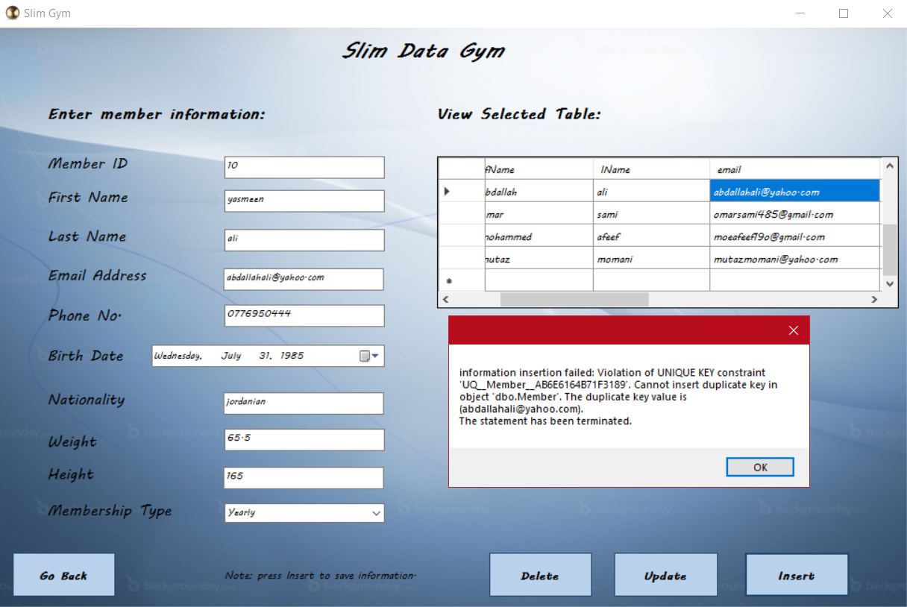

|  |  |  |  |  |  |
| --- | --- | --- | --- | --- | --- |
| Case ID | Test scenario description | Test steps | Expected result | Actual result | Status |
| TC_SG_003 | Class creation.  Test the creation of a new class in the database. | 1.Enter valid class information (classID, className, instructorName, duration, schedule).  2.Click the "Execute" button. | The class should be successfully created and stored in the database. | The class successfully created and stored in the database. | Pass |

Created new class called Cardio using MSSMS, and received a message stating 1 row is affected, after that I checked the Class table to view the actual result as the next figure.

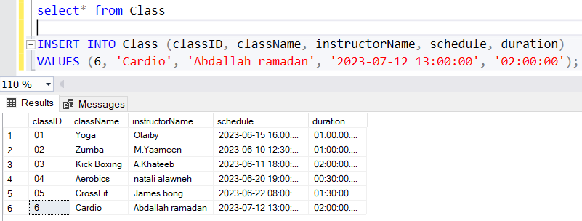

|  |  |  |  |  |  |
| --- | --- | --- | --- | --- | --- |
| Case ID | Test scenario description | Test steps | Expected result | Actual result | Status |
| TC_SG_004 | Nationality default value.  Verify that the system assigns a default nationality value when the user does not provide one. | 1.Enter member information without providing the nationality.  2.Click the "insert" button. | The system should assign the default nationality value of "Jordanian" to the member. | The system assigned the default nationality value of "Jordanian" to the new member. | Pass |

Entered the new member information according to the test steps and kept the nationality textbox empty and clicked the insert button, the system informed me with a pop-up message confirming the information insertion completed successfully, after that I checked the actual result in the database to confirm the expected result match the actual result.



